**Assignment -1**

|  |  |
| --- | --- |
| Assignment Date | 14 September 2022 |
| Student Name | Ms. VEMULA SRIJA |
| Student Roll Number | 111519106171 |
| Maximum Marks | 2 Marks |

Question 1: Draw the Circuit with Piezo alarm, PIR sensor, temp sensor using tinkercad and write the output

Circuit Diagram:

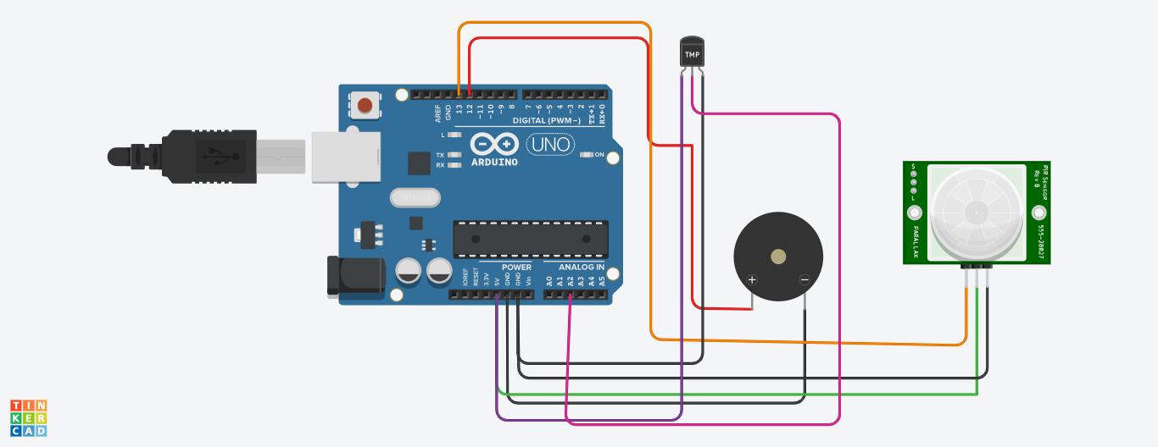

Code:

void setup()

{

Serial.begin(9600);

pinMode(13,INPUT);

pinMode(12,OUTPUT);

}

void loop(){

double data=analogRead(A2);

double n=data/1024;

double volt=n*5;

double off=volt-0.5;

double temperature=off*100;

int motion=digitalRead(13);

for(int freq=4;freq<=5;freq++) {

if(temperature>=60){

tone(12,freq);

delay(100);

}

else{

noTone(12);

}

}

for(int freq=2;freq<=3;freq++) {

if(motion==1) {

tone(12,freq);

delay(200);

}

else{

noTone(12);

}

}

}

Output:

Temperature is above 60

No Motion

No Motion

Temperature is below 60

Temperature is below 60

No Motion

No Motion

Temperature is below 60

Temperature is below 60

No Motion

No Motion

Temperature is below 60

Temperature is below 60

No Motion

No Motion

Temperature is below 60

Temperature is below 60

No Motion

No Motion

Temperature is below 60

Temperature is below 60

No Motion

No Motion

Temperature is below 60

Temperature is below 60

No Motion

No Motion

Video:-

https://drive.google.com/file/d/1RNj6UX-yxVP0Hi-GW91lKBGEOCYRXG1a/view?usp=sharing